**4. Sustainability Analysis**

USE world_bank_data;

-- Access to Electricity Over Time by country

SELECT country, date, access_electricity

FROM sustainable_indicators

ORDER BY country, date;

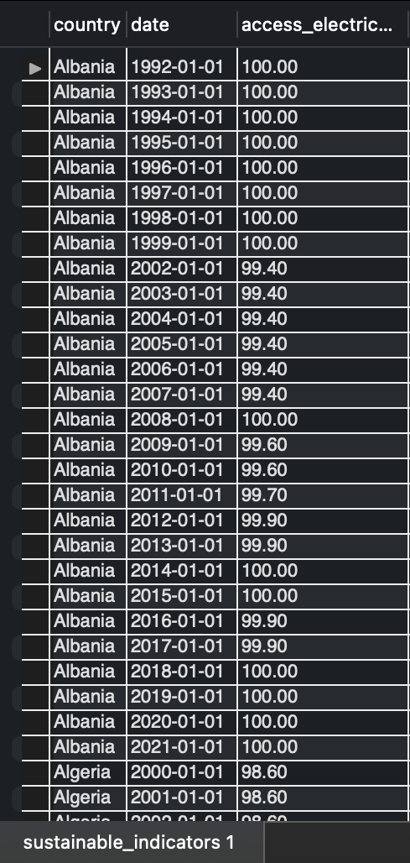

**Explanation:** This query retrieves access_electricity data for each country over time, ordered by country and date. It allows for an overview of changes in access to electricity across different years for each country.

-- Top 10 countries by renewable energy consumption

SELECT country, renewable_energy_consumption

FROM sustainable_indicators

WHERE date = (SELECT MAX(date) FROM sustainable_indicators)

ORDER BY renewable_energy_consumption DESC

LIMIT 10;

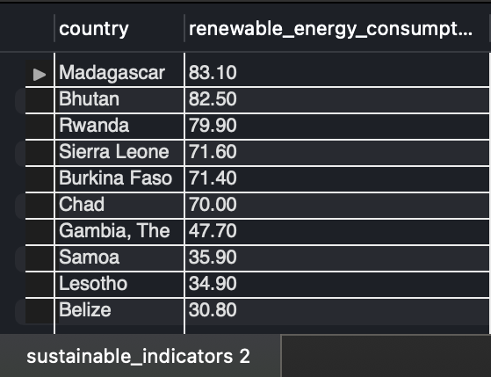

**Explanation:** Retrieves the top 10 countries with the highest renewable energy consumption based on the most recent data available, identifying global leaders in renewable energy utilization.

-- Average access to electricity by Region

SELECT region, AVG(access_electricity) AS avg_access_electricity

FROM sustainable_indicators

JOIN locations ON sustainable_indicators.location_id = locations.location_id

GROUP BY region

ORDER BY avg_access_electricity DESC;

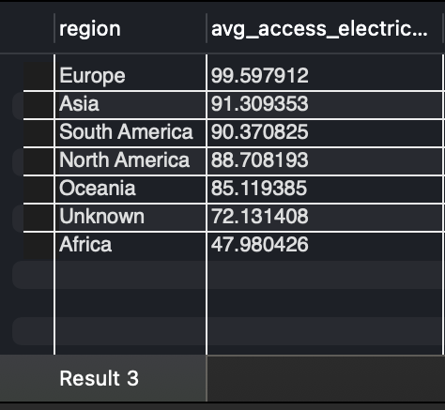

**Explanation:** Calculates the average access to electricity for each region, allowing for a comparison of electricity accessibility across regions. Regions with higher values indicate better infrastructure and access.

-- Yearly Renewable Energy Consumption for a specific country

SELECT YEAR(date) AS year, renewable_energy_consumption

FROM sustainable_indicators

WHERE country = 'Germany'

ORDER BY year;

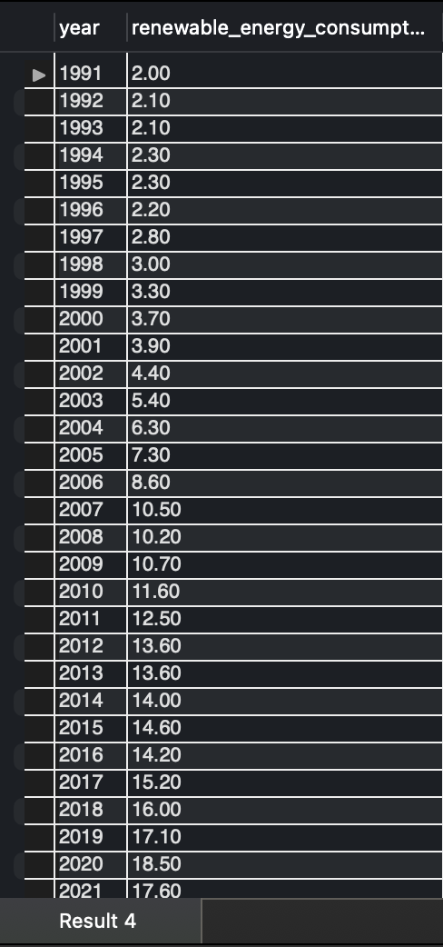

**Explanation:** Retrieves yearly renewable energy consumption data for Germany, providing insight into the country’s renewable energy usage trend over time.

-- Countries with low access to electricity (below 50%)

SELECT country, access_electricity

FROM sustainable_indicators

WHERE date = (SELECT MAX(date) FROM sustainable_indicators)

AND access_electricity < 50

ORDER BY access_electricity ASC;

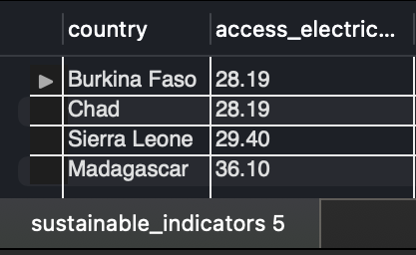

**Explanation:** Lists countries where access to electricity is below 50%, based on the latest data. This can highlight areas where infrastructure development may be needed.

-- View 1: for access to electricity by country

CREATE VIEW AccessElectricityByCountry AS

SELECT country, date, access_electricity

FROM sustainable_indicators

ORDER BY country, date;

-- Query this view

SELECT * FROM AccessElectricityByCountry WHERE country = 'India';

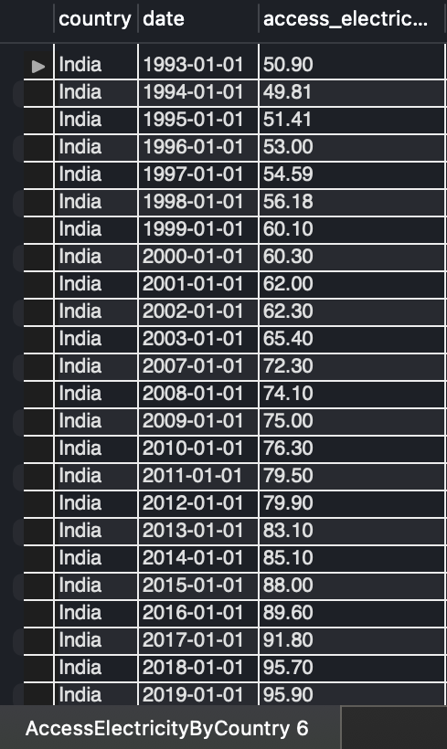

**Explanation:** Creates a view that captures access_electricity data by country over time. This view simplifies future queries for accessing electricity data by country.

-- View 2: for average renewable energy consumption by region

CREATE VIEW AvgRenewableEnergyByRegion AS

SELECT region, AVG(renewable_energy_consumption) AS avg_renewable_energy

FROM sustainable_indicators

JOIN locations ON sustainable_indicators.location_id = locations.location_id

GROUP BY region;

-- Use this view

SELECT * FROM AvgRenewableEnergyByRegion;

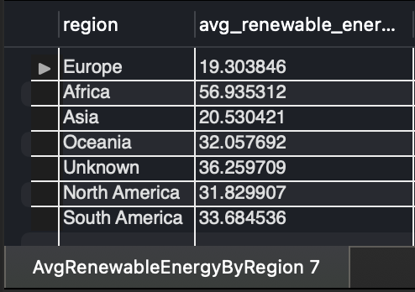

**Explanation:** Averages renewable energy consumption by region. This view is helpful for comparing regions based on their renewable energy usage.

-- View 3: yearly renewable energy consumption for each country

CREATE VIEW RenewableEnergyByCountry AS

SELECT country, YEAR(date) AS year, AVG(renewable_energy_consumption) AS avg_renewable_energy

FROM sustainable_indicators

GROUP BY country, year;

-- Use this view

SELECT * FROM RenewableEnergyByCountry WHERE country = 'Brazil';

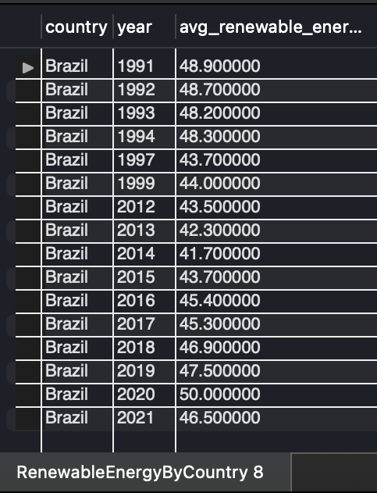

**Explanation:** This view captures average yearly renewable energy consumption for each country, making it easy to query renewable energy trends over time.

-- Stored Procedure 1: retrieve electricity access trends for a country

DELIMITER //

CREATE PROCEDURE GetElectricityAccessByCountry(IN country_name VARCHAR(50))

BEGIN

SELECT date, access_electricity

FROM sustainable_indicators

WHERE country = country_name

ORDER BY date;

END //

DELIMITER ;

-- Call this procedure

Call GetElectricityAccessByCountry('China');

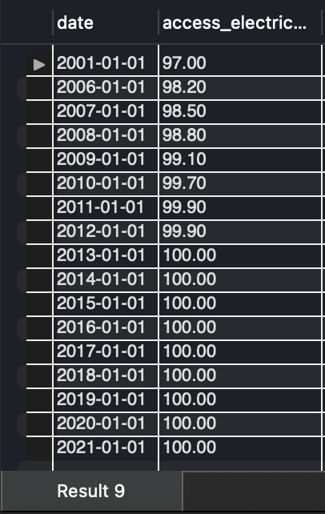

**Explanation:** This procedure retrieves electricity access data over time for a specified country, enabling a quick look at how access to electricity has changed.

-- Stored Procedure 2: to get average renewable energy consumption by region

DELIMITER //

CREATE PROCEDURE GetAvgRenewableEnergyByRegion(IN region_name VARCHAR(50))

BEGIN

SELECT region, AVG(renewable_energy_consumption) AS avg_renewable_energy

FROM sustainable_indicators

JOIN locations ON sustainable_indicators.location_id = locations.location_id

WHERE region = region_name

GROUP BY region;

END //

DELIMITER ;

-- Call this procedure

Call GetAvgRenewableEnergyByRegion('Europe');

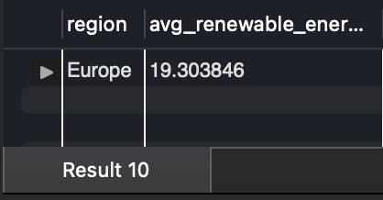

**Explanation:** This procedure calculates the average renewable energy consumption for a specified region, providing an insight into renewable energy adoption in that region.

-- Stored Procedure 3: to retrieve Top N countries by Access to Electricity

DELIMITER //

CREATE PROCEDURE GetTopCountriesByElectricityAccess(IN top_n INT)

BEGIN

SELECT country, access_electricity

FROM sustainable_indicators

WHERE date = (SELECT MAX(date) FROM sustainable_indicators)

ORDER BY access_electricity DESC

LIMIT top_n;

END //

DELIMITER ;

-- Call this procedure

CALL GetTopCountriesByElectricityAccess(5);

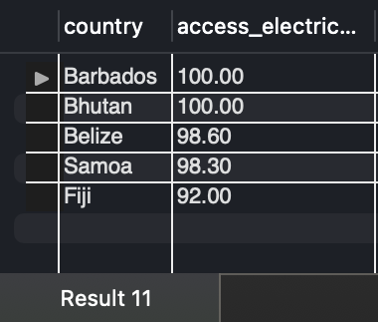

**Explanation:** Retrieves the top N countries with the highest access to electricity based on the latest data. This procedure highlights countries with well-established electricity infrastructure.

-- Function 1: Calculate Average Renewable Energy Consumption for a country

DELIMITER //

CREATE FUNCTION GetAvgRenewableEnergy(country_name VARCHAR(50))

RETURNS DECIMAL(5,2)

DETERMINISTIC

BEGIN

DECLARE avg_renewable DECIMAL(5,2);

SELECT AVG(renewable_energy_consumption) INTO avg_renewable

FROM sustainable_indicators

WHERE country = country_name;

RETURN avg_renewable;

END //

DELIMITER ;

-- Use this function

SELECT GetAvgRenewableEnergy('Canada');

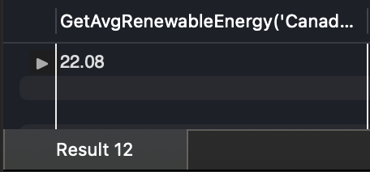

**Explanation:** This function calculates and returns the average renewable energy consumption for a specific country, helping to summarize a country’s renewable energy data.